- Discuss the 5 main activities involved in Requirements Engineering Process.
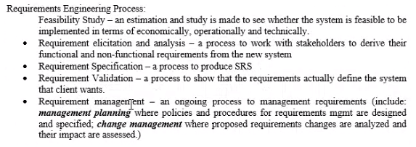

- Nobiana specializes in swimwear and clothing for women. Started in 1995 as a small scale mail order company, Nobiana has now grown into a multi-million pound and award winning organization.

Working with an independent outsourcing consultancy Zen, Nobiana decided to implement a new point-of-sales and inventory management system. The new project was driven by the need to simplify the way in which stock information and point-of-sales applications were delivered to retail stores and to enable this to be easily scalable in order to accelerate roll-out to existing or new stores, reduce ongoing administration and support costs while providing real time and accurate view of stock across the business, minimizing stock levels and streamlining ordering across the branches.

  - Suggest and briefly explain 2 techniques for discovering requirements for the above project.
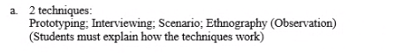

  - Assume that Zen is planning to adopt a viewpoint-oriented analysis method for the requirements analysis process. Describe viewpoint-oriented analysis in requirements analysis process.
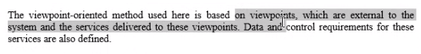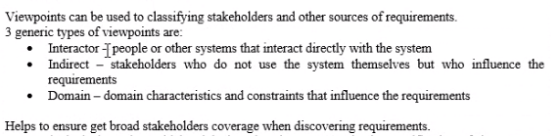

  - Suggest 5 principal viewpoints which should be considered in the process of discovering requirements for the above project. Construct a viewpoint hierarchy to present your viewpoints.
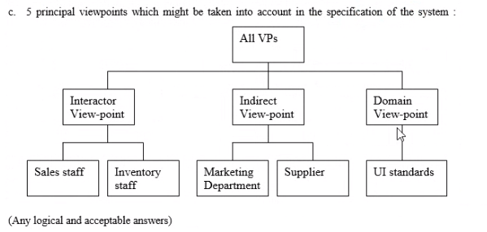

  - Discuss 2 advantages and 1 disadvantages of using viewpoint-oriented analysis method in requirement gathering and analysis.

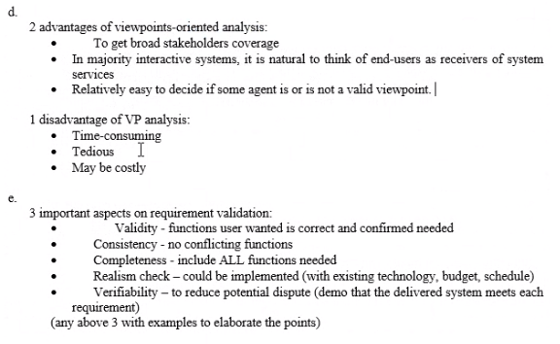

  - Suggest 3 aspects to be checked when validating the SRS for the above mentioned project.

- Discuss any 3 possible problems in Requirements Elicitation and Analysis process.
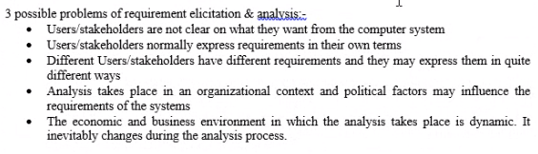

- Company KW is planning to develop an online document management system that is used by internal staff to store, share, and work on some confidential documents. You, and IT project manager, are responsible to manage this project with senior software engineers. Company KW requests you to deliver an initial version within 2 months and the subsequence increment within 2 months with active internal staff involvement.

Identify 3 viewpoints for the online document management system. Construct a viewpoint-oriented hierarchy for the system.
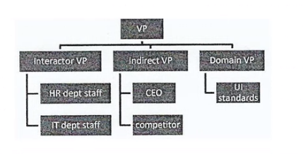

- Easy2Study.com is a global marketplace for teaching and learning online where students are mastering their skills. The system allows the students to search, view available courses, purchase, make payment, and join the courses. An access to start the course will be given once the payment is confirmed. Easy2Study.com is planning to extend their online system on mobile platforms to attract more customers as mobile users are increasing extremely.

As a software engineer for this project, you are required to prepare the system requirements document for Easy2Study.com mobile application. Recommend and explain 2 aspects that must be validated during Easy2Study.com SRS document validation process.
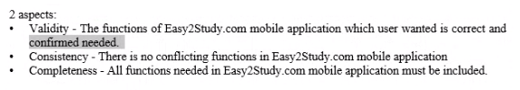
- Ladre is a small scaled family business found in 2000s which selling computers’ hardware and software. Recently the shop owner plans to improve the business by selling the products online. He has contacted your company as a suitable software house to handle this project.
Based on the case study, construct a viewpoint-oriented hierarchy for the online computer store system with 5 possible viewpoints. You must categorize your viewpoints under 3 categories (Interactor, Indirect, and Domain) with at least one viewpoint under each category.
